Warwick
Freestyle to Mozu
Interface

V1.0
05/05/2015

Table of Contents
1.0 Purpose 3
2.0 Scope 3
3.0 General App Information 4
3.1 Application/Integration Overview 4
3.2 Name of Application/Integration: 4
3.3 Purpose of Application/Integration 5
4.0 Functionality Interactions with Mozu 5
4.1 Commerce Functions Being Performed in 3rd Party System 5
4.2 Mozu Fields Being Modified by Application/Integration: 5
4.3 Installation, Integration and Usage 5
4.4 Configuration Instructions for Application/Integration in Mozu Admin 5
4.5 Environment(s) Where Plan to Install Application/Integration 5
5.0 Definitions 6
6.0 Revision History 6

FreeStyle to Mozu Interface

1.0 Purpose
This document describes the requirements of Application Program Interface (APIs) that which was created by Warwick Fulfillment Solutions to interface FreeStyle (Dydacomp) and Mozu E-Commerce solution.

2.0 Scope
Mozu is the data of record for order, customer and inventory information. Freestyle is the data of record for shipment information, which is used to update Mozu once the order has been shipped.

3.0 General App Information

3.1 Application/Integration Overview
As shown in the diagram below, Freestyle and Mozu communicate through an API which runs on a Mozu server and will be scheduled to transfer information based on the needs of the customer (hourly, on the ½ hour, etc…).
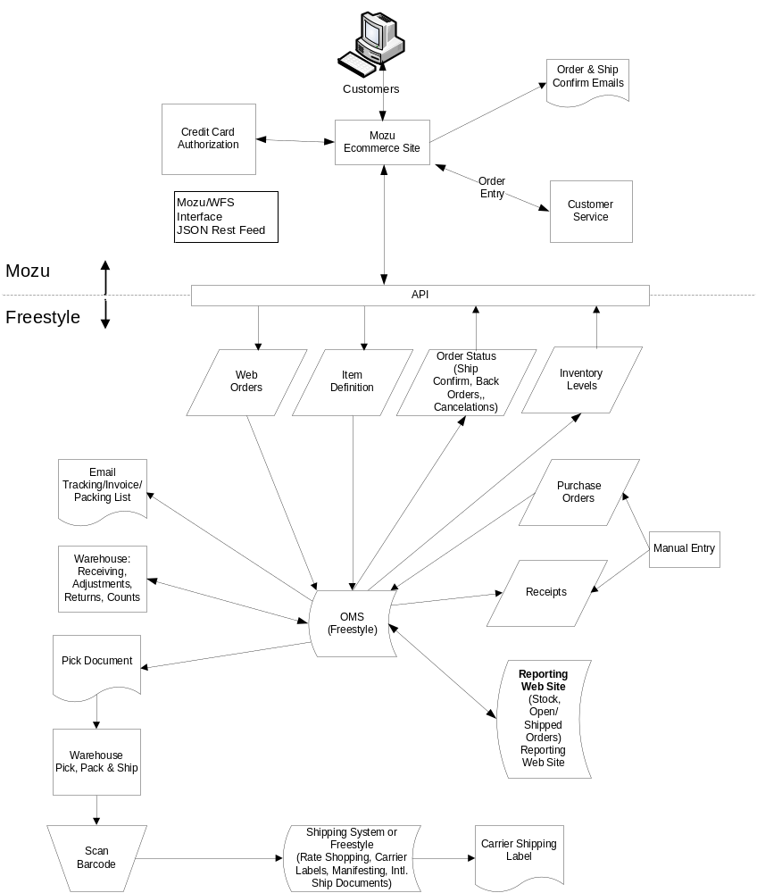

3.2 Name of Application/Integration:
Warwick Fulfillment Solutions – Mozu to Freestyle Integration

3.3 Purpose of Application/Integration
Transfer information between the Mozu E-Commerce platform and FreeStyle Order Management System. As shown in the diagram above the information that will be exchanged will be Orders, Items, Customer, Shipping and Inventory data.

4.0 Functionality Interactions with Mozu

4.1 Commerce Functions Being Performed in 3rd Party System
The FreeStyle system will be responsible for performing Order Management functions for all orders that are placed on the Mozu system. Order Management functions include the following:
- Inventory
- Order Management
- Customer Management
- Purchase Orders
- Reporting and Business Intelligence
- Shipping

4.2 Mozu Fields Being Modified by Application/Integration:
Fields being modified by the integration are:
- Order Table
  - OrderNumber
  - SubmittedDate
  - Subtotal
  - TaxTotal
  - DiscountedTotal
  - ShippingTotal
  - Total
- Shipment Table
  - Ship to Address

4.3 Installation, Integration and Usage
The MozuFreeStyleInterface.exe should be setup to run on a scheduler, the settings.xml file should be located in the same directory as where the MozuFreeStyleInterface.exe resides. When run, it will pass data between FreeStyle and Mozu by making API calls to both systems.

4.4 Configuration Instructions for Application/Integration in Mozu Admin
The configuration for Mozu and FreeStyle is a valid account and store setup in both systems with the userid’s and passwords in the settings.xml file.

The password key is generated using http://uttool.com/encryption/aes/default.aspx where the plain text field is your password for the site, the key is “1hI>=f'kUO9WGS;X/z=#wpy0$'M#|F%:“ when you select encrypt it will generate the password to be used in the settings.xml

4.5 Environment(s) Where Plan to Install Application/Integration
Windows environment with at least .NET 4.5.1.

5.0 Definitions
Terms Definitions
Application Program Interface (API) An API is a software intermediary that makes it possible for application programs to interact with each other and share data. It's often an implementation of REST that exposes a specific software functionality while protecting the rest of the application.

6.0 Revision History
Date of Change | Responsible | Summary of Change
May 6, 2015 | Wayne Bryan | Initial document creation

